EXPERIMENT-11

Performing IP Spoofing Using a GitHub Tool in Kali Linux

AIM

To demonstrate IP spoofing techniques using an open-source GitHub tool in Kali Linux for
understanding network-lovel attack concepts and security vulnerabilities.

Software Requirements

Host Operating System: Windows / Linux / macOS
Virtualization Software: Oracle VirtuaIBox
Guest Operating System: Kali Linux
Tool Source: GitHub (IP Spoofing Tool-Educational Use)
Programming Language: Python / Bash (as per tool)
System Requirements:
o RAM: Minimum 4 GB (8 GB recommended)
o Disk Space: Minimum 30 GB
o Processor: Intel/AMD with Virtualization support

Introduction

IP spoofing is a technique where an attacker forges the source IP address in network packets
to impersonate another system. It is commonly used in attacks such as DDoS, session
hijacking, and bypassing IP-based authentication. This experiment demonstrates IP spoofing
using a publicly available GitHub tool to understand how attackers manipulate packet
headers. Kali Linux provides a safe and controlled environment for ethical network security
experimentation.

Procedure

Step 1: Start Kali Linux Virtual Machine

1. Open Oracle VirtualBox.
2. Start Kali Linux
3. Log in using Kali credentials.

Step 2: Open Terminal
1. Launch Terminal in Kali Linux.
2. Update system packages:
3. sudo apt update

Step 3: Clone IP Spoofing Tool from GitHub

1. Clone the repository:
2. git alone https://github.com/<usemame>/<ip-spoofing-tool>
3. Navigate to the tool directory:
4. od ip-spoofing-tool

Step 4: Install Dependencies

1. Install required dependencies:
2. sudo apt install python?
3. pip3 install - requirements.txt

Step 5: Configure the Tool

1. Open the script file:
2. namo spoof.py
3. Configure:
4. Target IP address
5. Spoofed source IP address
Network interface

Step 6: Execute IP Spoofing

1. Run the tool with root privileges:
2. sudo python3 spoof.py
3. Observe packet transmission with spoofed IP addresses.

Step 7: Menitor Network Traffic (Optional)

1. Use Wireshark or topdump:
2. sudo tcpdump
3. Verify spoofed source IP packets.

OUTPUT:

Packets are sent with forged source IP addresses.
Network traffic reflects spoofed IP information.
Demonstration successfully completed
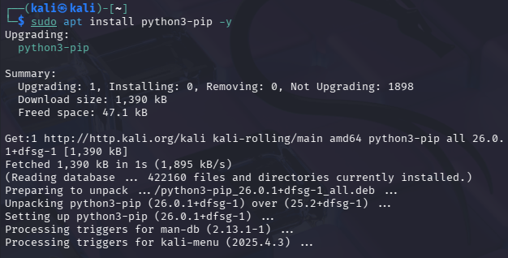
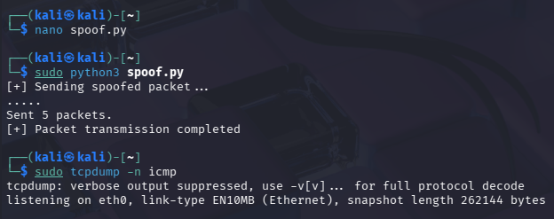

Result

IP spoofing was successfully demonstrated using a GitHub-based tool in Kali Linux.
The experiment illustrates how attackers can manipulate IP headers and highlights the need
for robust network security mechanisms

